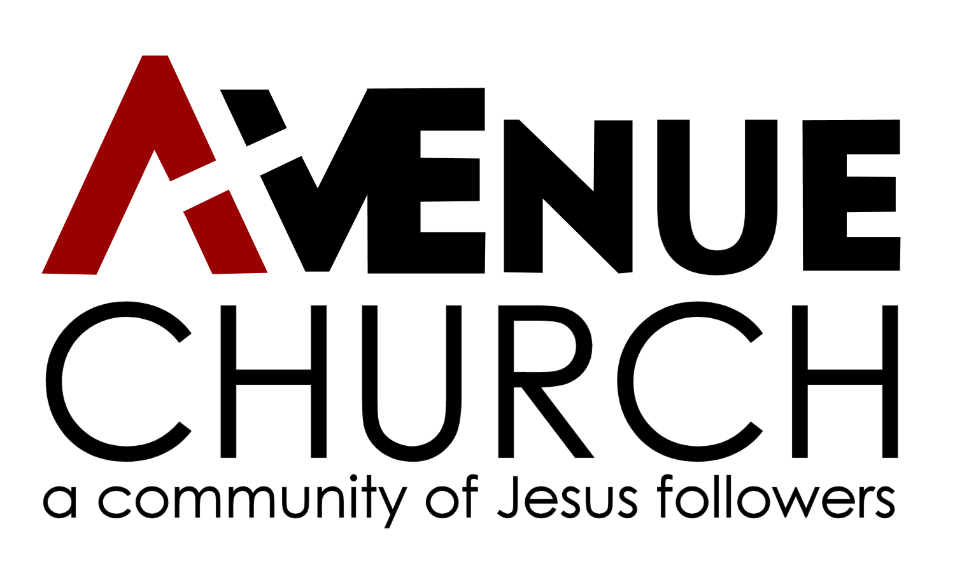
Associate Pastor
of Worship and Youth Ministry
at the Avenue Church
315 Columbia Avenue
Glasgow, KY 42141
(270) 651-8501

Church Overview
The Avenue Church is a non-denominational community of Jesus followers in Glasgow, KY. Our mission is to attract and connect people to Jesus and his body, so that together we are transformed for his service. Our congregation has roots in the Stone-Campbell Movement and Churches of Christ, but our members come from many faith traditions. We have been in a season of transition in an attempt to reach unchurched people in our community which has included a shift toward a more contemporary style of worship, and we are seeking someone who can help lead us in this direction. Our worship is currently blended a capella and instrumental, and our goal is to transition to an emphasis on instrumental and contemporary music.

We have roughly 100 attendees on Sundays ranging from young children to retirees, including a few youth-group students. Currently our gatherings consist of one Sunday worship gathering and Sunday Bible Classes for all ages. Our worship team includes a number of vocalists, a regular pianist, and an occasional guitarist. We’ve been live-streaming our services for a number of years, and are constantly working to improve that ministry. We’re heavily involved in community ministry through feeding programs, homeless ministry, and a clothing house, and are actively seeking to develop ties with other Christian communities and organizations in our area.

Job Overview
We are seeking a man or woman to work alongside the recently hired (Aug ‘21) Lead Pastor to lead our congregation into this new direction by guiding our weekly worship as we seek to attract members of our community to Jesus, and by helping to pastor our students. This role is a full-time position, and we envision the Associate Pastor to spend about 70% of his or her time leading the worship ministry, and about 30% leading the youth ministry (these percentages are not set in stone, but are intended to give a sense of our desired priorities). Salary is negotiable and commensurate with experience.

Qualifications
- A mature and growing relationship with Jesus Christ
- A desire to live out the mission of the Avenue Church
- A passion for leading people to experience Jesus Christ through worship and teaching
- Ability to effectively lead worship services that include traditional and contemporary elements
  - Preference will be given to candidates who are proficient in the guitar
- Ability to effectively relate to young people, especially youth group students (6th-12th)
- Bachelor’s degree or equivalent experience
  - Degrees in Bible, Ministry, Church Music, or related fields are appreciated but not required

Job Responsibilities

Worship Ministry
- Work with the Lead Pastor and worship committee to plan weekly worship gatherings (currently Sunday morning)
- Lead all musical aspects of the weekly worship gathering including:
  - Develop and equip worship teams made up of instrumentalists and vocalists
  - Organize and lead worship team practices
- Utilize planning software such as Planning Center to prepare everyone involved in each week’s worship in advance of Sunday
- Help lead the congregation towards more contemporary worship styles
- Proactively pursue creative and dynamic methods for engaging the congregation in worship
- Oversee volunteers for technical aspects of worship (audio, visual, livestream, etc.)
- Plan and coordinate special worship gatherings (e.g. Christmas Eve, “Worship Nights,” etc.)
- Oversee annual budget needs for worship ministry

Youth Ministry
- Work alongside Lead Pastor and adult volunteers to plan and oversee youth ministry (6th-12th grade) programming and activities
- Develop relationships with youth-group age students in the congregation
- Enlist, equip, and shepherd adult volunteers to assist in youth ministry programming
- Coordinate teachers for, and regularly teach, Sunday youth Bible Class
  - Expected to be a regular presence in youth Bible Class, but not teach every week
- Help coordinate regular (~monthly) youth activities outside of weekly Bible Class
- Help coordinate 1-2 larger annual activities for youth (retreats, camps, service weeks, etc.)

Other Responsibilities
- Work alongside the Lead Pastor on a strategic level to plan events, encourage vision, and implement strategies for pursuing the mission of the Avenue Church
- Maintain regular office hours
- Communicate regularly with Lead Pastor and elders regarding plans, ideas, and vision
- Be available to fill other ministerial needs, such as teaching Bible classes, preaching, visiting members of the congregation, and any other necessary duties
- Actively participate in the life of the congregation
- Attend all necessary meetings with the elders and Lead Pastor

Interested?
Please submit a resume to our Lead Pastor at Joel@avechurch.org. Feel free to contact us with any questions.

